Test (Units 1 & 2)
№1 Choose the correct answer

1) You need a passport to cross the …. between Mexico and the United States.
A. edge B. line C. border D. rim
2) The hotel where we’re …. is quite luxurious.
A. living B. remaining C. existing D. staying
3) Once we get to the hotel, let’s just …. quickly and then do a bit of sightseeing.
A. set down B. make up C. check in D. turn up
4) There’s a …. outside the station, so you’ll have no problems getting a taxi.
A. taxi rank B. terminal C. tram
D. check-in counter
5) The ship sank on its maiden …. .
A. trip B. journey C. voyage
D. travel

№2 Complete the sentences with the affirmative, negative or interrogative form of used to/would and the verbs in the box. 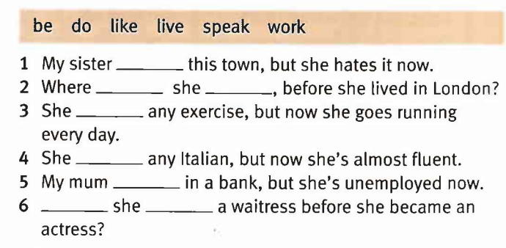
№3 Form negative adjectives from the words in bold.
1) My younger sister is very ……………. She doesn’t believe in recycling. | RESPONSIBLE
2) People who believe that there is no global warming are ….. | INFORMED
3) She thought it was ……………….. that the winter was so warm. | USUAL
4) UK men arrested for ……………… sale of ivory. | LEGAL
5) I find some Maths problems …………. to solve! | POSSIBLE
6) John and I don’t get on well. We always ………….. about everything. | AGREE
7) Pam was ………………. to her sister. | POLITE

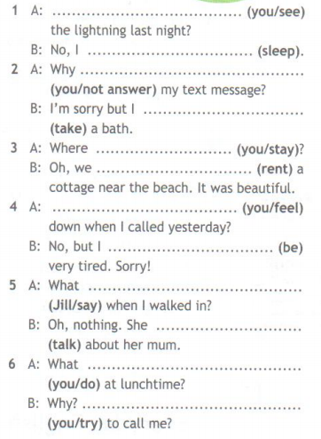
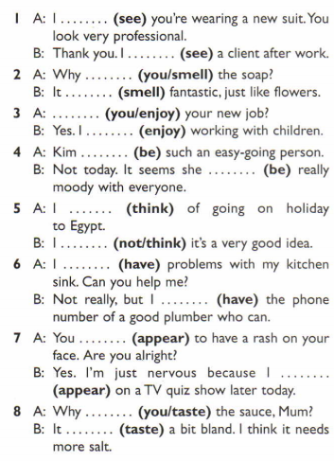
№ 4 Put the verbs in the brackets into the present simple or present continuous.
№ 5 Put the verbs in the brackets into the past simple or past continuous.

№ 4 Put the verbs in the brackets into the present simple or present continuous.

№6 Choose the correct word.
1. Kate was disappointed / disappointing with the book. She expected it to be much better.
2. It was quite surprised / surprising that Jeremy passed his exams with flying colours.
3. Mr. Brown didn’t find the situation funny. He was not amused / amusing.
4. Adam is really exciting / excited about going to the Netherlands next month.
5. I don’t like this kind of weather. It is so depressing / depressed.
6. I was shocked / shocking by how shocked / shocking the accident was last night.
7. John was confusing / confused by the confusing / confused street signs in the city.
№ 7 Translate these words.
1 | ferry
2 | ловкость
3 | guidebook
4 | similar
5 | достопримечательность
6 | tram
7 | провожать
8 | fare
9 | граница
10 | плата за проезд
11 | frenetic
12 | противник

№8 Choose the correct answer.
1) Alice met a friend of her / hers.
2) Excuse me, is this your / yours seat?
3) We didn’t eat ours / our sandwiches.
4) Tom has borrowed my / mine pen.
5) You can’t have any chocolate! It’s my / mine.
6) My pencil is broken. Can I borrow your / yours?
7) These grammar books are different. Your / yours has 278 pages, but my / mine has only 275.
8) My telephone is out of order, but his / their is working.

